**1. ReactJS-HOL**

**myfirstreact**

**App.js**

import React from 'react';

import './App.css';

function App() {

  return (

    <div className="App">

        <h1>Welcome to the first session of React</h1>

    </div>

  );

}

export default App;

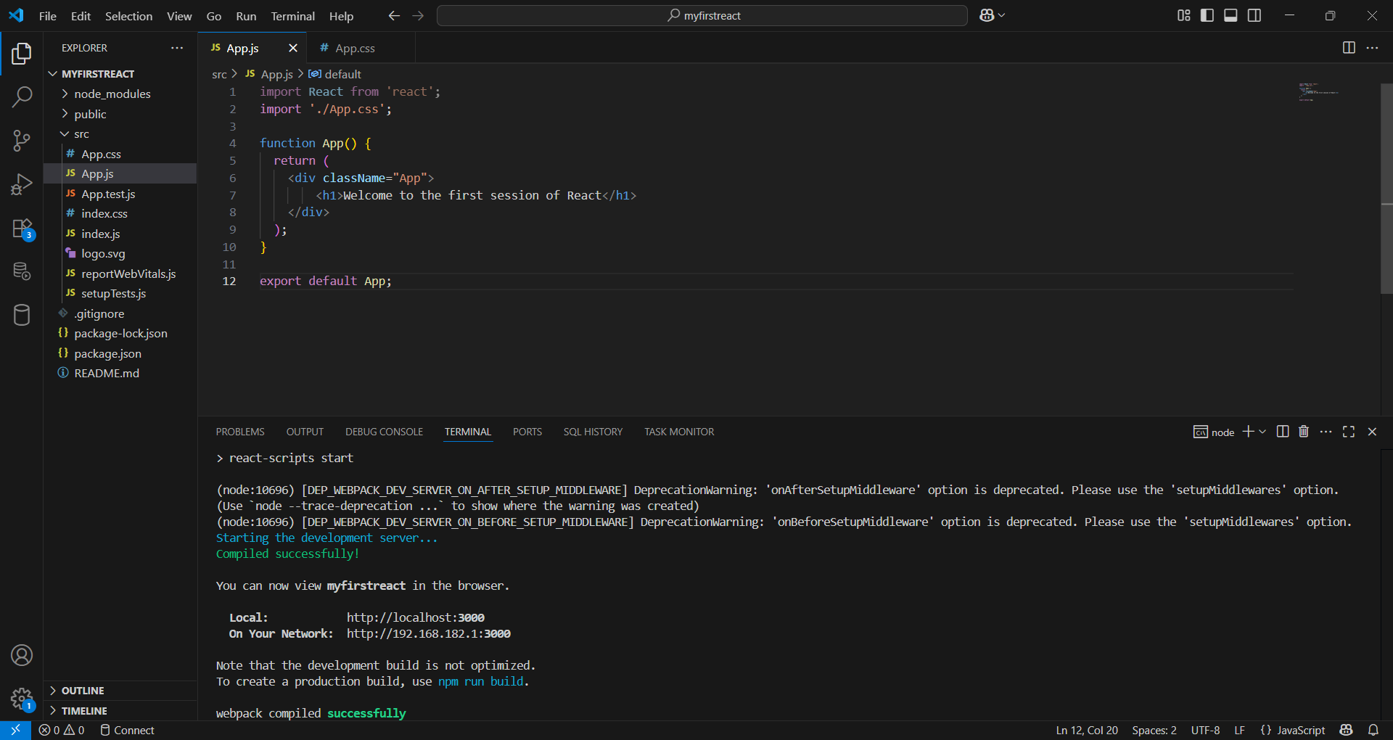

**Output:**

